D530 User’s Guide
to Research Insight

Created by Kate Moore
Assistant Librarian at the IUS Library
812-941-2489 (Reference Desk)
Created Fall 2010
Revised: 25 September 2013
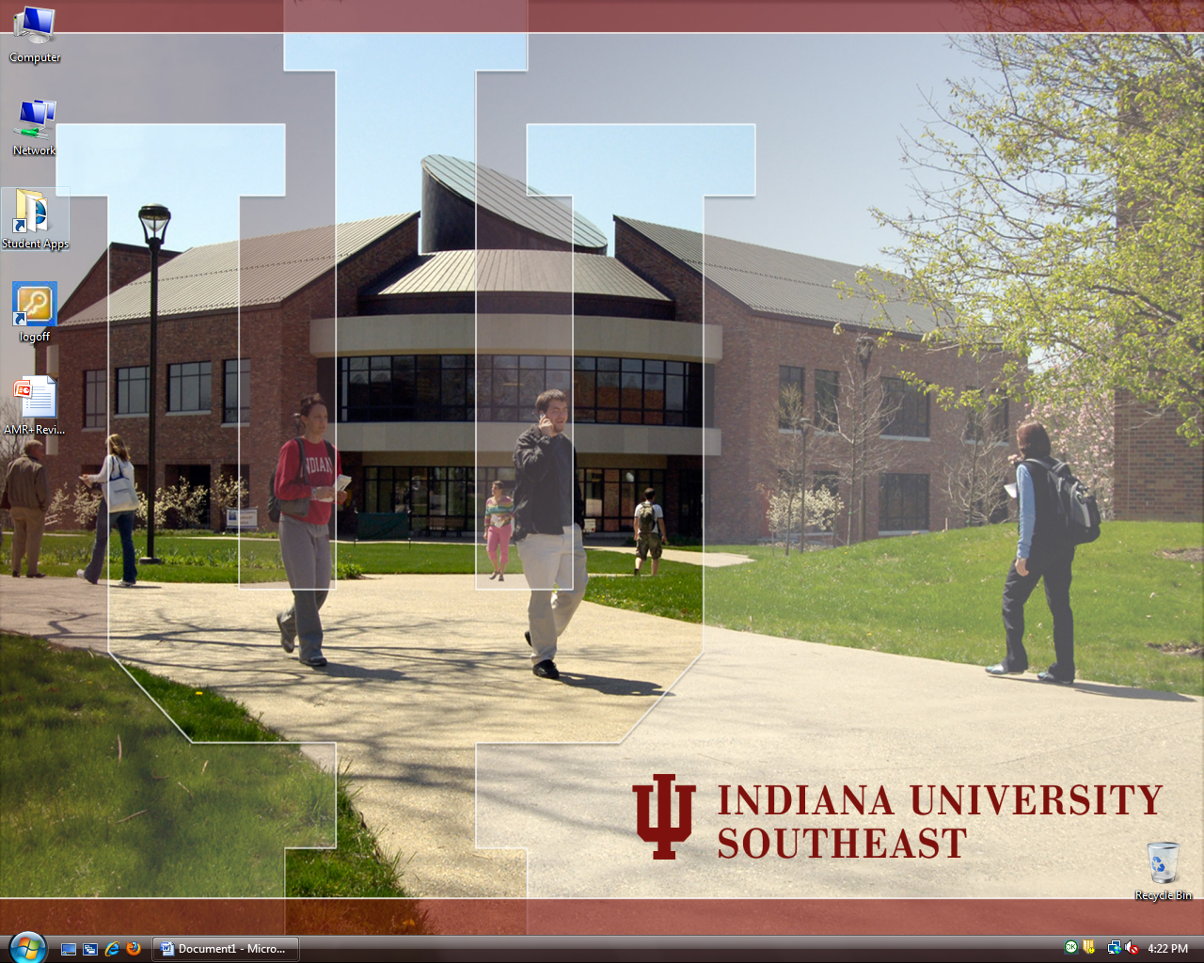
Installing Research Insight (RI) on your computer on campus:
- Go to the Student Apps folder on your Desktop.

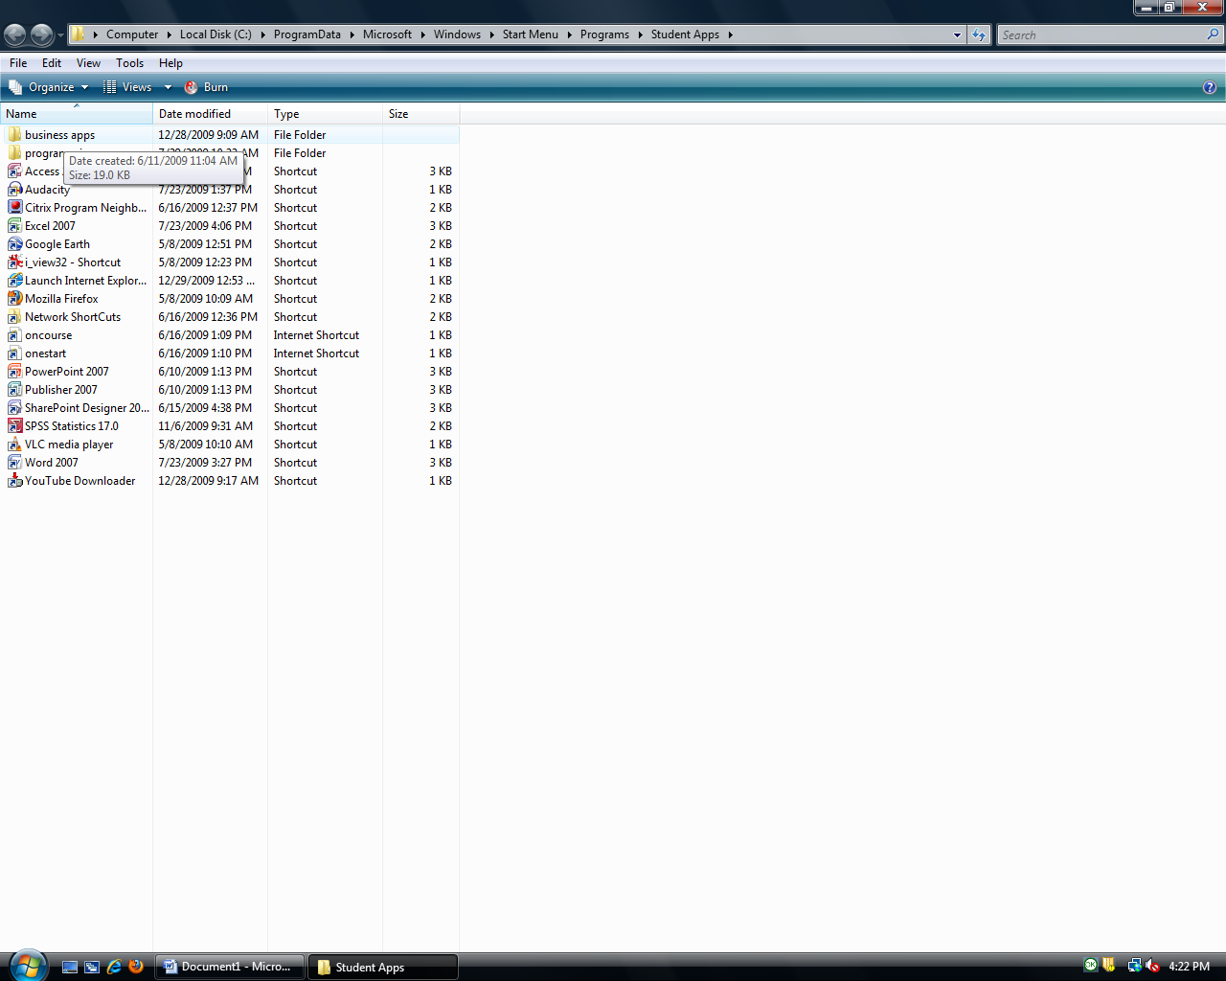
- Go to the business apps folder (inside Student Apps).
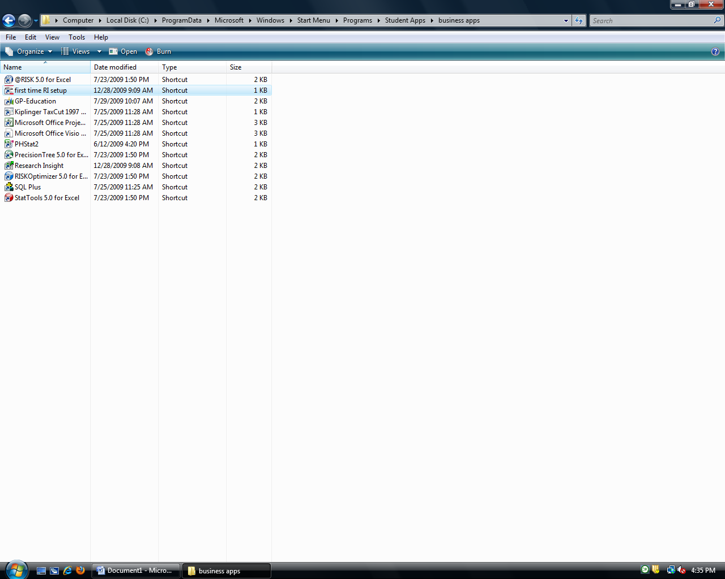
- Double click on “first time RI setup” (this may need to be done even if you’ve already installed Research Insight on a different computer on campus). RI should install itself on your computer.

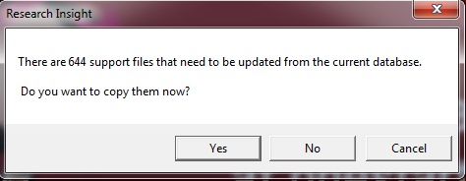
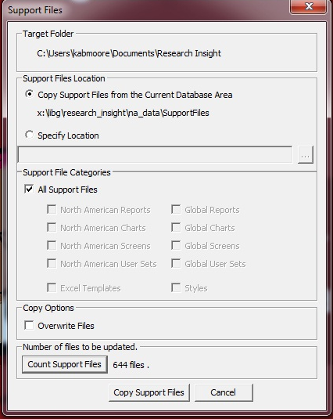
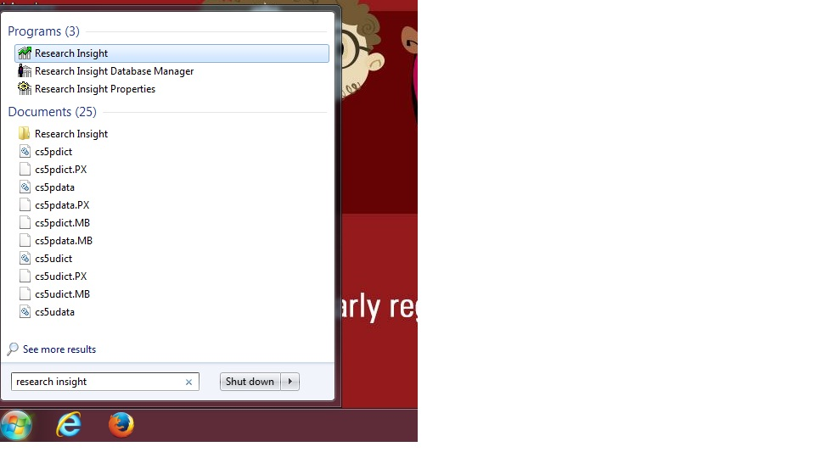
- a. Click on the Window Ribbon, type in “Research Insight” in the
search box, and select the Research Insight program.
b. You will then be asked if you want to copy files onto the computer.
Click “Yes.”
c. Click on "Copy Support Files" when prompted.
Research Insight should open automatically when all
support files have been copied.
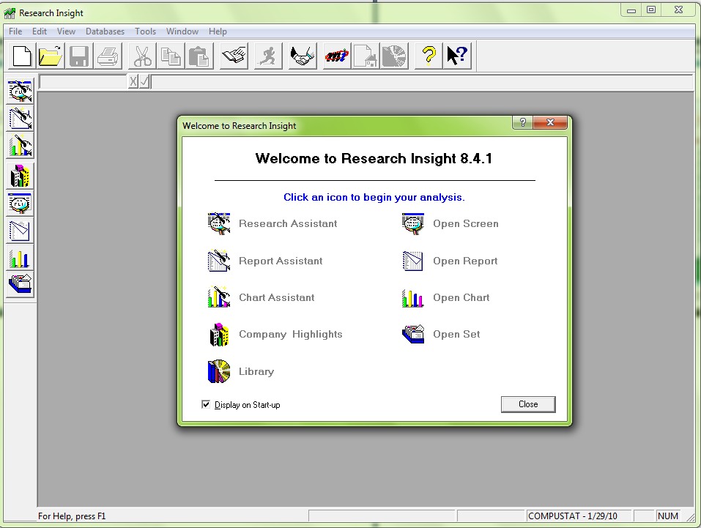
- RI’s opening screen. Click close.

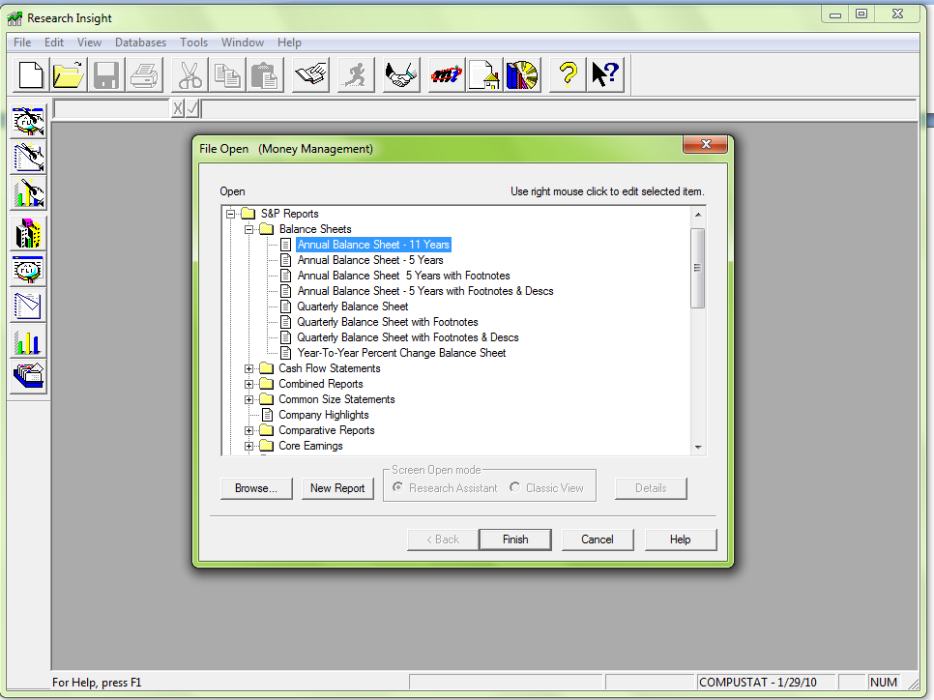
Retrieving Annual Balance Sheets:
- Click on Open Report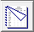.
- Find Balance Sheets in the menu and click to open the folder.
- Click on Annual Balance Sheet – 11 years.
- Click Finish.
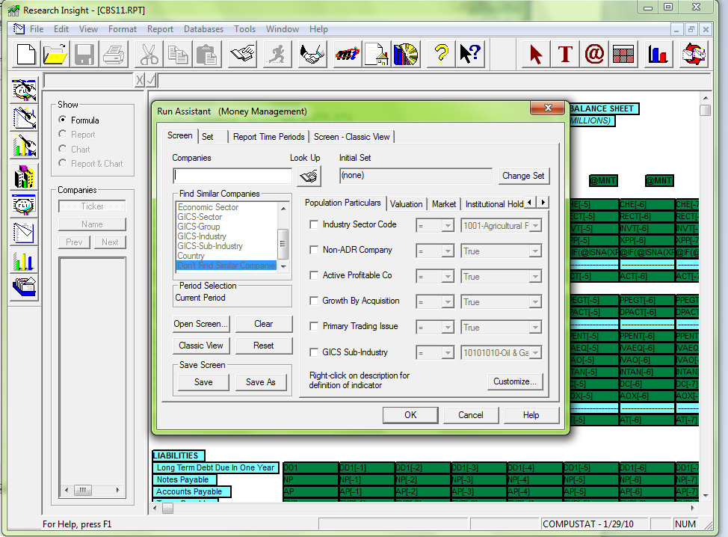

- If you know the ticker of your company, enter it in the Companies field, click OK, and proceed to page 11. If not, see next 2 pages.

If you don’t know your company’s ticker, click on Look Up.

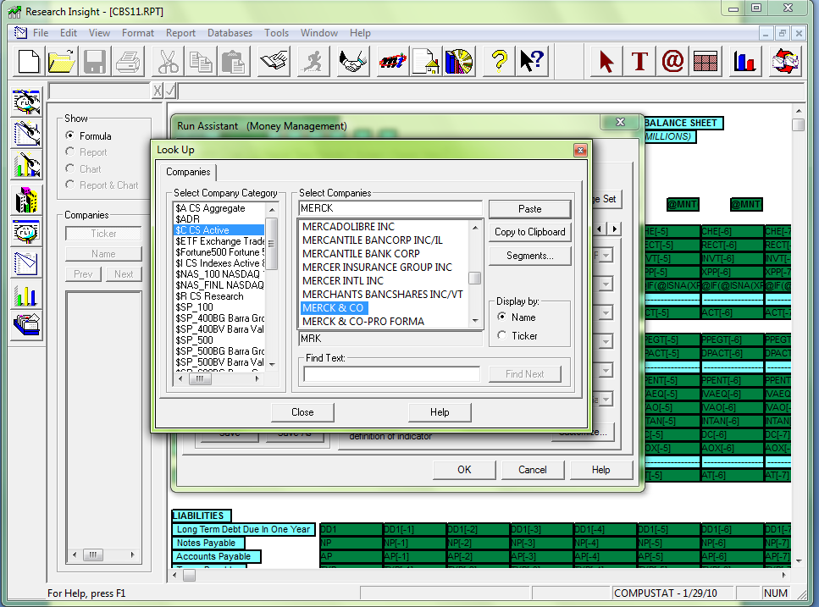
- Type your company’s name into the Select Companies field.
- Make sure it’s highlighted in the dropdown box.
- Click Paste.
- Click Close.
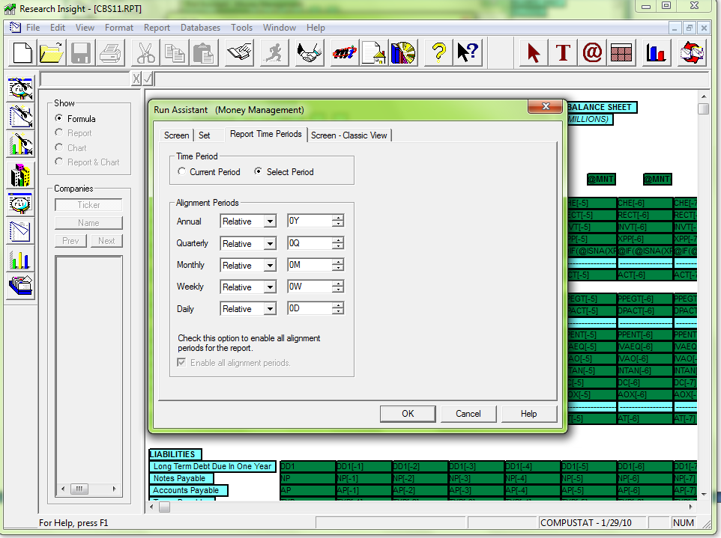
- To change the years viewed in the Annual Balance Sheet, go to the Report Time Periods tab.
- Click on Select Period.

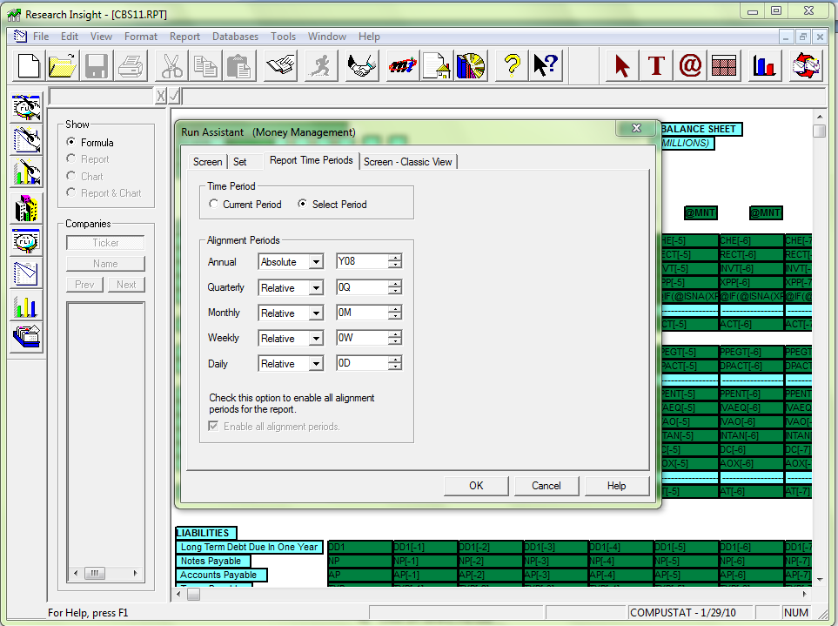
- For a specific time frame, change the “Alignment Period” to Absolute.
- Change the year to the last one needed (this will be the most current year reported on the Balance Sheet).
- Click Okay.

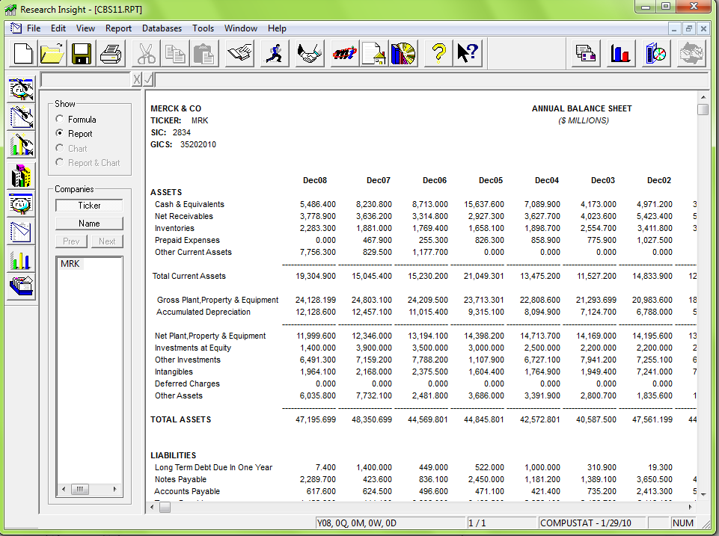
- Annual Balance Sheet in RI.
(Click on blue X to close just the Annual Balance Sheet).

To Modify Your Report:

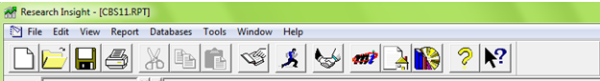

- Click on the button in the top menu. You will then be taken back to the “Run Assistant” screen (shown below).

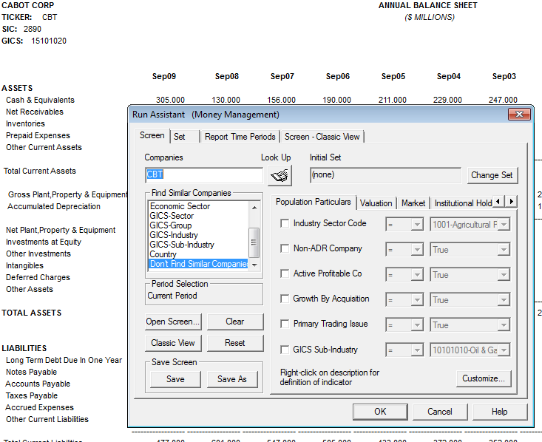
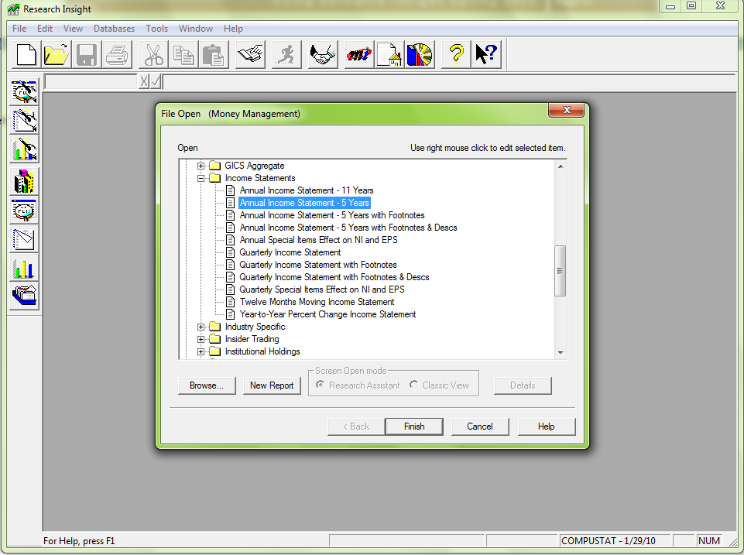
Retrieving Annual Income Statements:
- Click on Open Report.
- Scroll down to find Income Statements in the menu and click to open the folder.
- Click on Annual Balance Sheet – 5 years.
- Click Finish.

- If you know the ticker of your company, enter it in the Companies field, and go to page 18. If not, see next 2 pages.
If you don’t know your company’s ticker, click on Look Up.
- Type your company’s name into the Select Companies field.
- Make sure it’s highlighted in the dropdown box.
- Click Paste.
- Click Close.
- To change the years viewed in the Annual Income Statement, go to the Report Time Periods tab.
- Click on Select Period.
- For a specific time frame, change the Annual Alignment Period to Absolute.
- Change the year to the last one needed (this will be the most current year reported on the Income Statement).
- Click Okay.

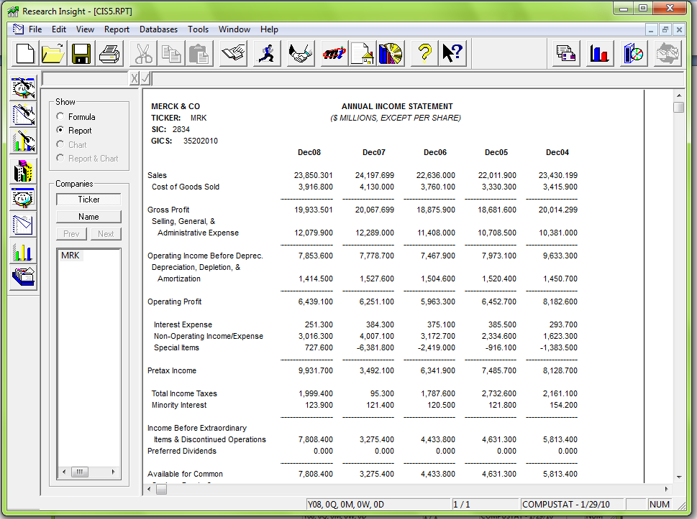
- Annual Income Statement in RI.
(Click on blue X to close just the Annual Income Statement).

Finding Definitions:
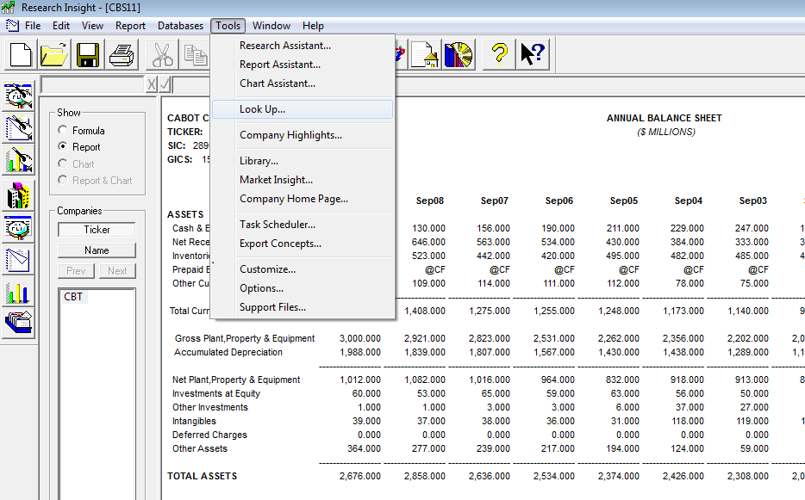
- Go to the “Tools” menu.
- Click on “Look Up.”

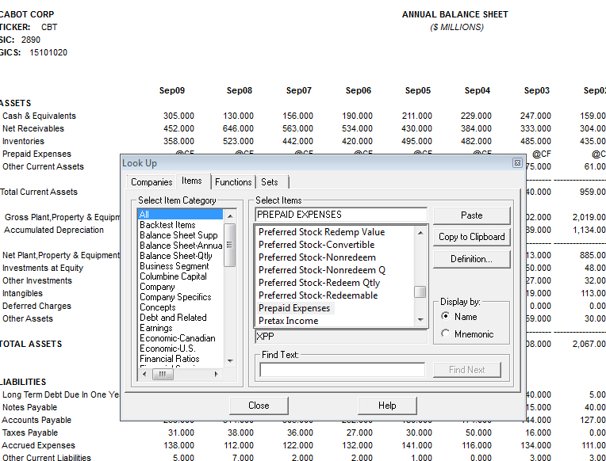
- From the Look Up Menu, Select “Items.”
- Type in the financial item you’re uncertain about.
- Click on Definition.

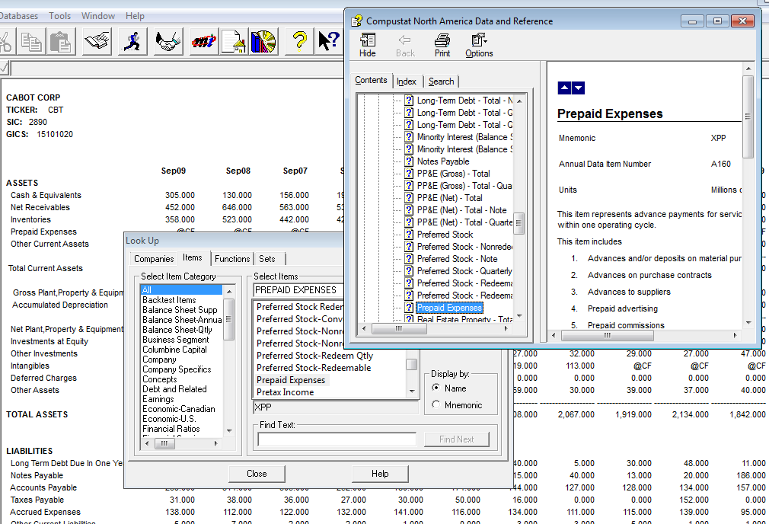
A Help Menu will pop up with a description of the financial item.

